**COMP1350 2020 – ASSIGNMENT ONE**

|  |
| --- |
| **Student ID: 46460306**  **Student Name: Syed Adeel Asghar**  **Tutor’s Name: Sarah Ali Siddiqui**  **Class Number: C20** |

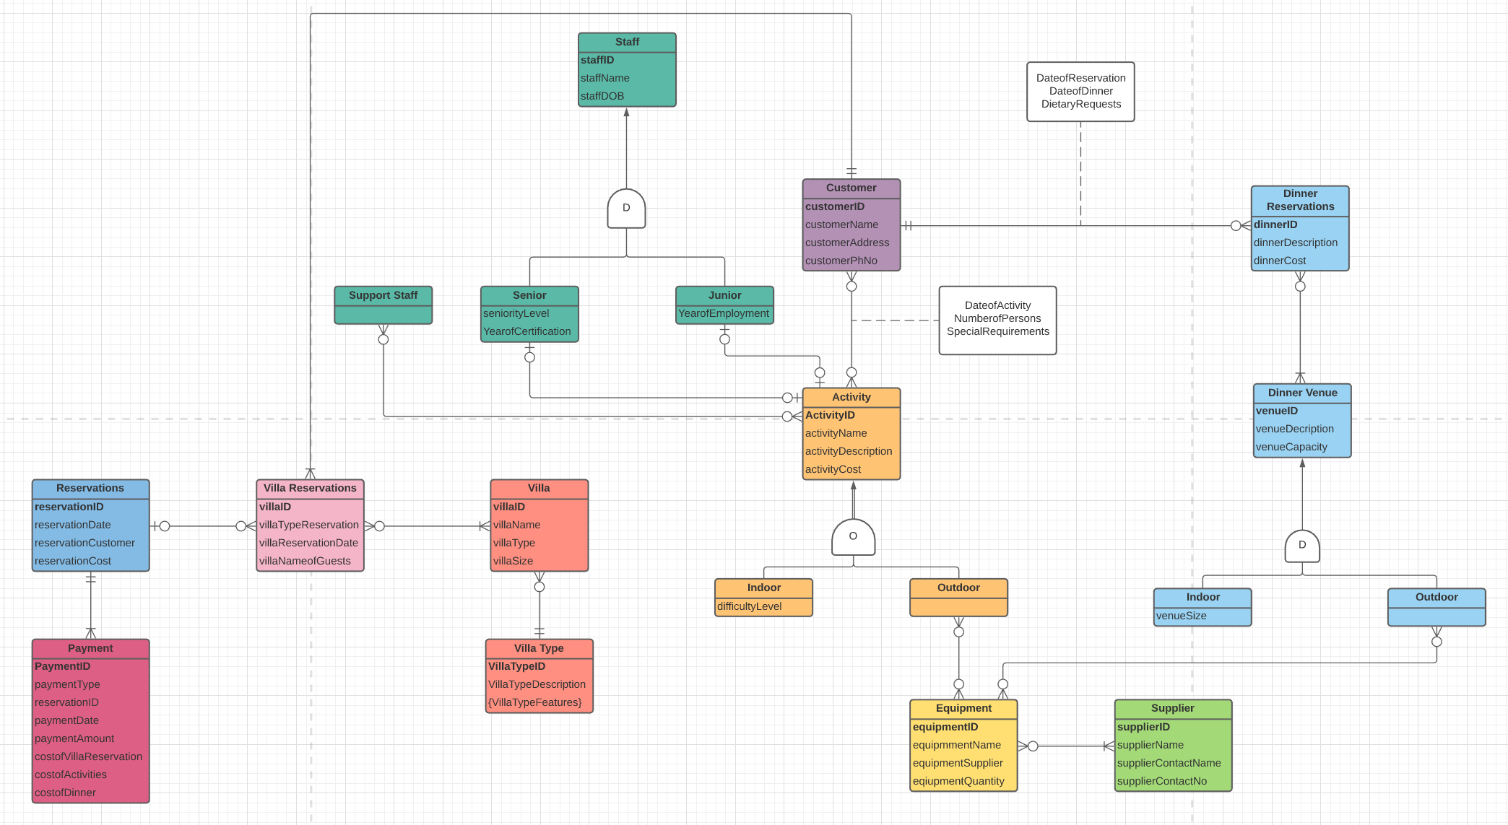Task 1: EER Diagram

Assumptions, if any:

* All bolded attributes are PKs
* Payment entity also collects all details regarding costs
* villaType can either be connected to many or no other villa
* Equipment can be supplied by many suppliers but must be from one
* Suppliers can provide different types of equipment or none at all to this resort.
* Customer can have reservations for one or many villas and a single reservation can only belong to one customer and must belong to someone
* There must be one senior and junior staff present for all activities but there could be none if that activity isn’t running that day or if no customers have booked it
* A customer can make numerous dinner reservations or none, but a single reservation belongs to max 1 customer and must belong to someone
* Dinner reservations could be made for multiple venues and must occur somewhere and there are numerous reservations for one venue but there could also be none if there are no reservations made for a particular day
* Outdoor venues use multiple types of equipment or none if there are no outdoor dinner reservation made and vice vera; equipment is issued to multiple outdoor venues, but none could also be issued if there are no outdoor dinner reservations
* Reservations could be made for multiple villas or none if the customer decides not to stay over for a night but when made a villa belongs to a single reservation for one customer or could belong to no one if no reservations are made for that villa.

Task 2: Logical Transformation

Step 1 – dinnerReservations (**dinnerID(PK)**, dinnerDescription, dinnerCost)

dinnerVenue (**venueID(PK)**, venueDescription, venueCapacity)

Customer (**customerID(PK)**, customerName, customerAddress, customerPhNo)

Equipment (**equipmentID(PK)**, equipmentName, equipmentSupplier, equipmentQuantity)

Step 2 – no weak entities

Step 3 – no 1:1 relationships

Step 4 – dinnerReservations (**dinnerID(PK)**, *customerID(FK)*, *venueID(FK),* dinnerDescription, dinnerCost)

Step 5 – Location (**dinnerID(PK,FK)**, **venueID(PK,FK)**)

Step 6 – no MVAs

Step 7 – Dinner (dinnerID(PK,FK), customerID (PK,FK), DateofReservation, DateofDinner, DietaryRequirements)

Therefore, the final tables are:

Customer (**customerID(PK)**, customerName, customerAddress, customerPhNo)

dinnerReservations (**dinnerID(PK)**, *customerID(FK)*, *venueID(FK),* dinnerDescription, dinnerCost)

dinnerVenue (**venueID(PK)**, venueDescription, venueCapacity)

Equipment (**equipmentID(PK)**, equipmentName, equipmentSupplier, equipmentQuantity)

Dinner (dinnerID(PK,FK), customerID (PK,FK), DateofReservation, DateofDinner, DietaryRequirements)

uses_Equipment (equipmentID(PK,FK), venueID(PK,FK))

---------------------------------------------------------------------------------------------------------------------------------------------------------------------------------------------

Step 8a – Indoor (**venueID(PK,FK),** venueSize)

Outdoor (**venueID(PK,FK)**)

---------------------------------------------------------------------------------------------------------------------------------------------------------------------------------------------

Repetition of steps 2-7:

Step 2 - no weak entities

Step 3 – no 1:1 relationships

Step 4 – dinnerReservations (**dinnerID(PK)**, *customerID(FK)*, *venueID(FK),* dinnerDescription, dinnerCost)

Step 5 - uses_Equipment (equipmentID(PK,FK), venueID(PK,FK))

Location (**dinnerID(PK,FK)**, **venueID(PK,FK)**)

Step 6 – no MVAs

Step 7 – Dinner (dinnerID(PK,FK), customerID (PK,FK), DateofReservation, DateofDinner, DietaryRequirements)

---------------------------------------------------------------------------------------------------------------------------------------------------------------------------------------------

Step 8b – Indoor (**venueID(PK)**, venueDescription, venueCapacity, venueSize)

Outdoor (**venueID(PK)**, venueDescription, venueCapacity)

Step 8c – cannot be completed as the diagram is of a disjoint constraint

Step 8d – dinnerVenue (**venueID(PK)**, venueDescription, venueCapacity, venueSize, isIndoor, isOutdoor)

---------------------------------------------------------------------------------------------------------------------------------------------------------------------------------------------

Therefore, the final tables, including step 8a are:

Customer (**customerID(PK)**, customerName, customerAddress, customerPhNo)

dinnerReservations (**dinnerID(PK)**, *customerID(FK)*, *venueID(FK),* dinnerDescription, dinnerCost)

dinnerVenue (**venueID(PK)**, venueDescription, venueCapacity)

Equipment (**equipmentID(PK)**, equipmentName, equipmentSupplier, equipmentQuantity)

Dinner (dinnerID(PK,FK), customerID (PK,FK), DateofReservation, DateofDinner, DietaryRequirements)

uses_Equipment (equipmentID(PK,FK), venueID(PK,FK))

Location (**dinnerID(PK,FK)**, **venueID(PK,FK)**)

Indoor (**venueID(PK,FK),** venueSize)

Outdoor (**venueID(PK,FK)**)

Task 3: Normalisation

Table is given in 1NF

Need to convert to 2NF and 3NF…

**2NF:**

Table_1 = **MenuItemID**, MenuItemName

Table_2 = **DressCode**, DressCodeDescription, DinnerCode, DinnerCost

Table_3 = *MenuItemID*, *DressCode*,PortionSize

**3NF:**

Table_1 = **DinnerCode**, DinnerCost, *DressCode*

Table_2 = **MenuItemID**, MenuItemName

Table_3 = *DinnerCode*, *MenuItemID*, PortionSize

Table_4 = **DressCode**, DressCodeDescription

*NOTE – **Bold =** PK *Italicized =* FK